
Project Concept: biz2code — A Linear Gatekeeper for Business-Validated Development
Project Summary: An end-to-end Linear Gatekeeper that forces the Founder to act like a PM, forces the PM to act like an Architect, and gives the Developer a pristine, clear, production-ready business insight.
Problem: Independent developers often lack business and market analysis experience, while founders, product managers, and business developers rarely have the time for rigorous idea validation. This gap allows unproven concepts to reach development without a clear understanding of business viability, resulting in costly mistakes for both independent builders and time-constrained decision-makers.
Current Solutions & Unique Value Proposition (UVP): General-purpose LLMs offer inconsistent capabilities, are prone to hallucination and sycophantic responses, and typically lack the structured, multi-perspective analysis needed for sound business decisions — on target audience, cost, and product-market fit.
Current Solutions — Core Issue:
The deeper issue is what we term AI blind spots: an LLM has no inherent way of knowing which tools, data sources, or analytical frameworks a given business idea actually needs. This is a human judgment call that changes case by case, not something a model can reliably infer.
biz2code UVP:
biz2code solves this through targeted prompt engineering that constrains the LLM into a rigid, sequential Gatekeeper process: each stage requires human-approved decisions before proceeding, keeping every choice grounded in the app's stated goals and business plausibility rather than the model's own assumptions.

Deliverables:
- Business Suite — a consolidated Business Plan, MRD, and PRD covering market and product analysis and go-to-market planning
Optional:
- Dynamic Project Ledger (Dashboard) — a live, continuously updated dashboard tracking business goal, selected architecture, and phase-completion status
- Financial Dashboard — a live model within the Business Suite tracking revenue projections, cumulative CapEx/OpEx, budgeting, and profit
- Solution Architecture Document (SAD) — system topology, data architecture (ERD schemas), API strategy, and security/authentication protocol
- Handoff.md — a development-ready architecture document derived from the validated business logic

- Where is the software? Make sure that biz2code is an application
It will be a local App.
- It's over-scoped- make sure you are on the project timeframe
The Architecture, product development parts may also be optional.
- Does "Linear" mean the project-management tool Linear (i.e. you're integrating with it), or just "sequential/step-by-step"? Step by Step

What is missing from the scope:
- Tech stack and architecture of biz2code itself, the data/state model for the gates, auth (multi-user?), how outputs persist, and deployment.
The General Idea:
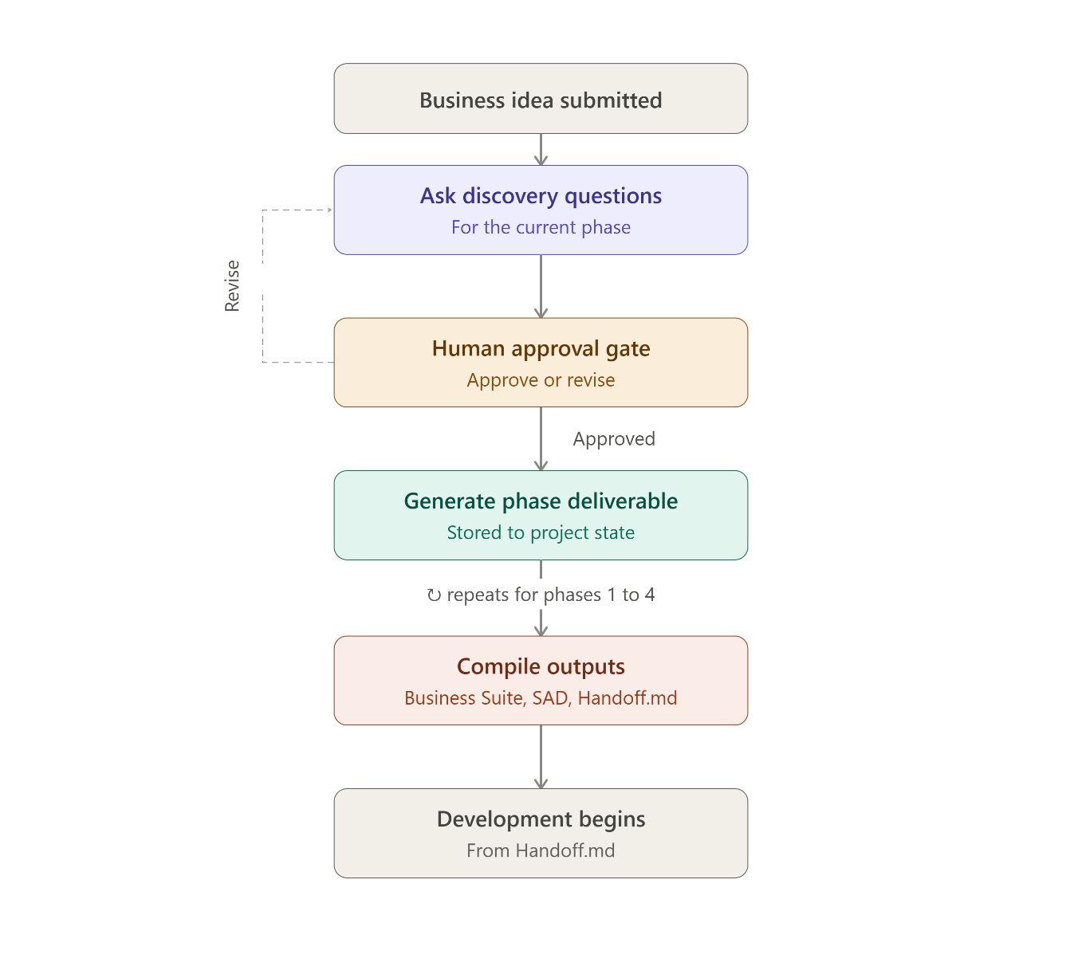

The Demo part:
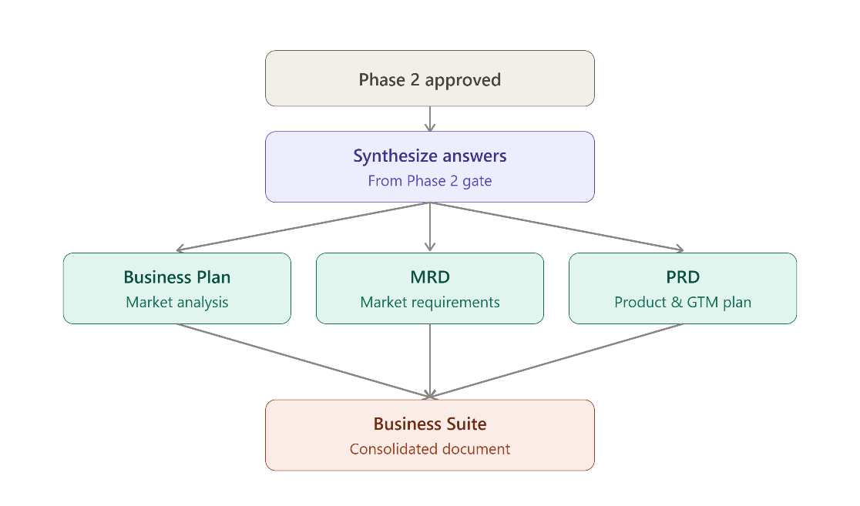

Tech stack and architecture:
React ──REST/JSON──▶ Express API ──▶ Postgres
│
└──HTTPS──▶ LLM provider (server-side only)
- Data/state model for the gates
Project — one business idea being run through the pipeline. Holds currentPhase and overall status.
Phase — one row per project per phase. Holds status: pending | in_progress | awaiting_approval | approved | revising, plus approvedAt.
Question — the discovery questions for a phase, with order (so the sequence is enforced) and optional dependsOnQuestionId for the conditional branching from your earlier flowchart (e.g. the platform-choice branch).
Answer — one per question per project, the founder's actual response.
Deliverable — the generated output for a phase (Business Suite section, SAD section, etc.), with its content and a version number, since a revise cycle produces a new version rather than overwriting the old one.
Gate logic, concretely: a phase cannot move to approved without every non-skipped Question in it having an Answer, and advancing currentPhase on the Project is only permitted when the current phase's status is approved. That's the whole engine — everything else is UI around this state machine.
- Auth - single-user for the MVP:
one User table, simple email/password with JWT in an httpOnly cookie, no roles, no tenant scoping. Every Project just belongs to a userId

- How outputs persist
Final documents persist as files — when all questions are approved, the compile step renders the stored deliverable content into the downloadable documents (Business Suite) as Markdown or DOCX, written to disk and served via a download endpoint. — writing to a local /outputs directory the Express server can serve is sufficient.
- Deployment:
Local Only - Concretely: npm run dev runs Express

- Explicit success criteria / demo plan: what does "done" look like, and what will you show on presentation day? The Demo will consist of a live demonstration of the process, by inserting an idea for an App in the input, and a set of questions will be asked by the App, and after all the required questions will be answered, then a Business analysis file will be made.

